This document provides a step-by-step walkthrough for creating and managing sections in your truenorthlogic portal. Your portal will reflect your organizations naming convention and configuration choices.

# Creating a Section

* From your **Home** screen, locate and click the **Course Proposal** tab
* Click the **Course Projects** link.
* Locate your course in the **Current Projects** section and using the **Actions** menu click **Edit Course**.

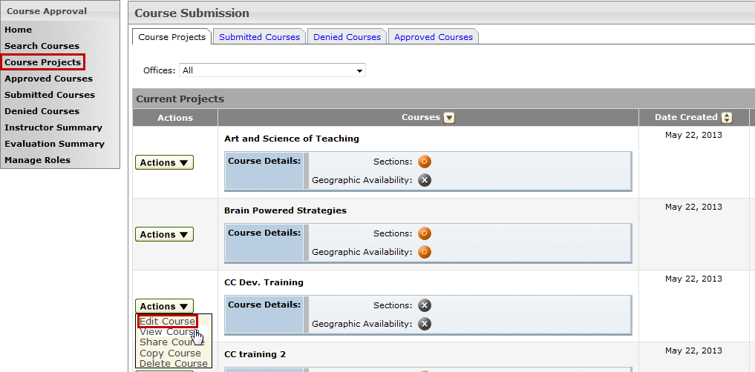

* In the **Manage Course** window click Edit Course.

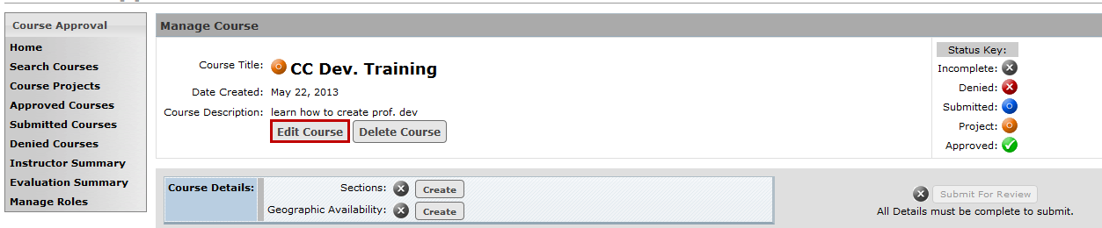

* Scroll down and click **New Section** to begin the section creation process.

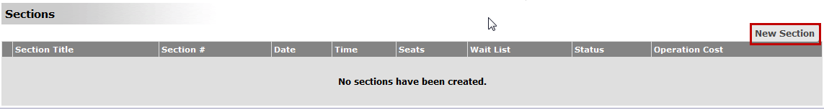

* Complete the form to create your section. Required fields are in **red**. Your fields will reflect your district’s needs. Once required information has been entered, click **Create** to create the section.
* Click **Cancel** to return to the previous screen.

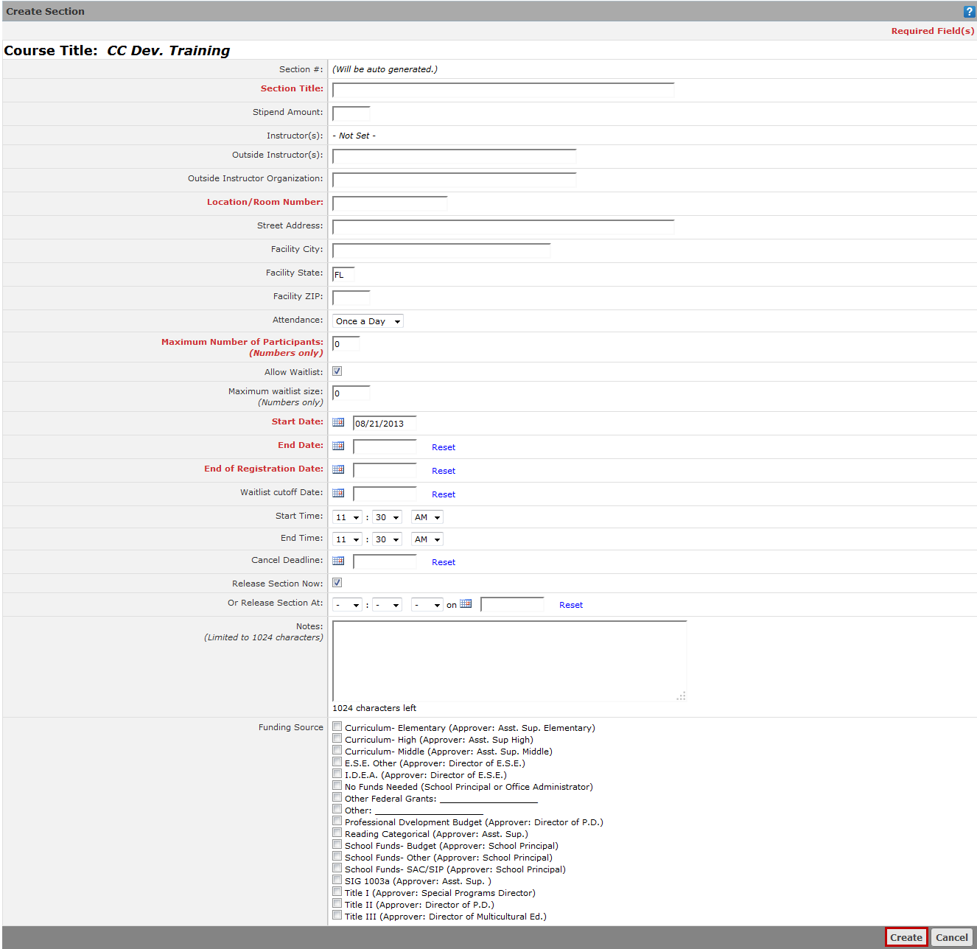

* Depending on your configuration, you may **Manage** (add) **Instructors,** **Manage** (set) **Class Times**, or edit the section by clicking **Manage Course** as determined by your district.
* Click **Done** to create the section
* Click **Edit** to make any changes to your section.

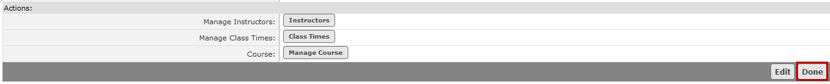

* Click **Done** from the **Manage Course** page to complete the process and save your section.
* Repeat these steps to create additional sections for your course.

